IV. Use Case Diagram

1. Overall Use Case

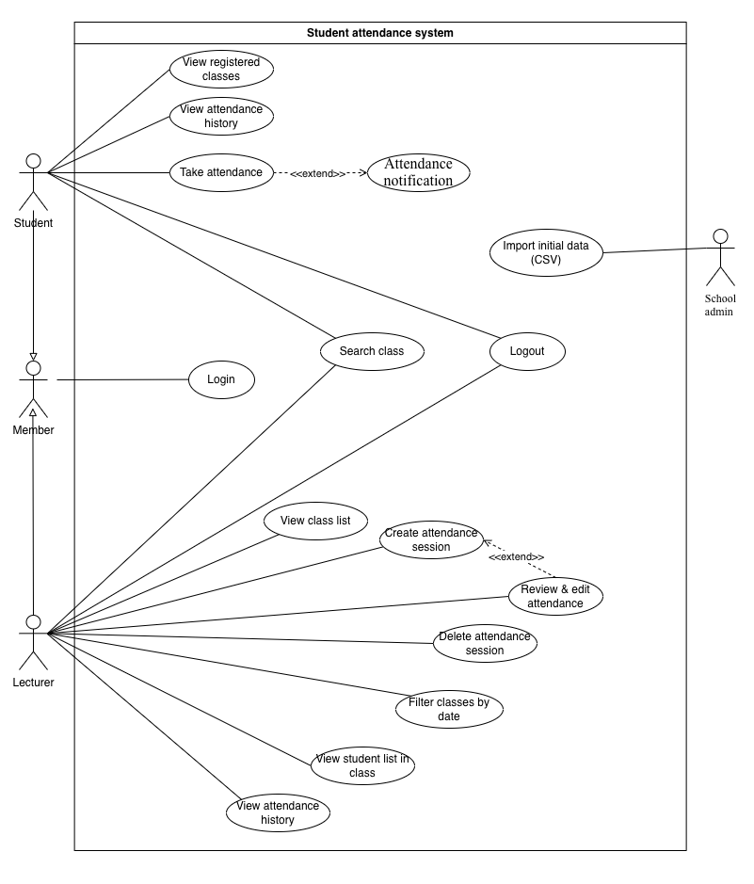

7. Use-case Filter Classes by Date

7.1. Summary
This use case allows a lecturer to filter the list of classes they are teaching by a specific date in order to view classes scheduled on that day.
The filtering result includes only the classes taught by the currently logged-in lecturer.

7.2. Flow of Events

7.2.1. Main Flow
- The lecturer has successfully logged into the system.
- The lecturer is on the View class list screen.
- The lecturer enters the desired date in DD/MM/YYYY format.
- The lecturer selects the Filter classes by date function.
- The system checks the class schedule data stored in the class_schedule.csv file.
- The system filters and displays the classes that:
  - Have a scheduled date matching the entered date
  - Have a lecturer email matching the email of the currently logged-in lecturer
- The system displays the list of classes that meet the conditions (course name, class ID, class time, etc.).

7.2.2. Alternative Flows

7.2.2.1. No classes on the selected date
- If no classes satisfy the filtering conditions, the system displays the message: “No classes are scheduled on the selected date.”

7.2.2.2. Invalid date format
- If the lecturer enters an invalid date format, the system displays the message: “Invalid date format. Please enter the date in DD/MM/YYYY format.”

7.3. Special Requirements
- The entered date must follow the DD/MM/YYYY format.
- The lecturer can only view classes they are responsible for and cannot view classes taught by other lecturers.
- The filtering operation does not modify the original data stored in the CSV files.

7.4. Pre-conditions
- The lecturer has logged into the system.
- Class and schedule data have been loaded from CSV files.
- The system is currently displaying the lecturer’s class list.

7.5. Post-conditions
- The class list is displayed based on the selected date.
- No changes are made to the stored data.

7.6. Extension Points
- Use-case View class list (this use case is performed on the displayed class list).

8. Use-case View Registered Classes

8.1. Summary
This use case allows a student to view the list of classes they have registered for after logging into the system.
The class list is automatically filtered based on the student’s ID.

8.2. Flow of Events

8.2.1. Main Flow
- The student logs into the system successfully.
- The student selects the View registered classes function.
- The system retrieves the student’s information from the loaded data.
- The system determines the classes that the student has registered for.
- The system displays the class list (course name, class ID, schedule).

8.2.2. Alternative Flows

8.2.2.1. Student has not registered for any classes
- The system displays the message: “You have not registered for any classes.”

8.3. Special Requirements
- The student can only view their own registered classes.
- Data modification is not allowed.

8.4. Pre-conditions
- The student has logged in.
- Class data has been loaded.

8.5. Post-conditions
- The registered class list is displayed.

8.6. Extension Points
- Use-case Take attendance
- Use-case View attendance history

9. Use-case Create Attendance Session

9.1. Summary
This use case allows a lecturer to create an attendance session for a class, including the start time, end time, and an optional attendance password.

9.2. Flow of Events

9.2.1. Main Flow
- The lecturer logs into the system successfully.
- The lecturer selects a class they are teaching.
- The lecturer selects the Create attendance session function.
- The lecturer enters:
  - Start time
  - End time
  - Password (if any)
- The system creates a new attendance session.
- The system stores the session information in the sessions.csv file.
- The system initializes the list of present students (svcomat) as empty.

9.2.2. Alternative Flows

9.2.2.1. Invalid time
- If the end time is earlier than the start time, the system displays an error message.

9.3. Special Requirements
- Each class can have only one active attendance session at a time.
- The lecturer can only create sessions for classes they teach.

9.4. Pre-conditions
- The lecturer has logged in.
- The class exists and is under the lecturer’s responsibility.

9.5. Post-conditions
- A new attendance session is created and stored.

9.6. Extension Points
- Use-case Attendance notification

10. Use-case Attendance Notification

10.1. Summary
This use case allows the system to display notifications about the status of an attendance session, including the remaining time or the ended status.

10.2. Flow of Events

10.2.1. Main Flow
- An attendance session is successfully created.
- The system displays notifications:
  - Attendance session is active
  - Remaining time
- When the session expires, the system updates the notification to: “Attendance session has ended.”

10.3. Special Requirements
- Notifications are updated automatically in real time.
- Students cannot interact with the notifications.

10.4. Pre-conditions
- An attendance session has been created.

10.5. Post-conditions
- The attendance session status is displayed correctly.

10.6. Extension Points
- Use-case Create attendance session

11. Use-case Take Attendance

11.1. Summary
This use case allows a student to confirm their attendance in an active attendance session.

11.2. Flow of Events

11.2.1. Main Flow
- The student logs into the system successfully.
- The student accesses a class with an active attendance session.
- If a password is required, the student enters the password.
- The student enters “present” to confirm attendance.
- The system records the student as present.
- The system updates:
  - svcomat
  - sobuoihoc

11.2.2. Alternative Flows
- Incorrect password
- Duplicate attendance attempt
- Attendance session has expired
(The system displays corresponding messages.)

11.3. Special Requirements
- Each student can take attendance only once per session.

11.4. Pre-conditions
- The student has logged in.
- An attendance session is active.

11.5. Post-conditions
- Attendance status is updated.

11.6. Extension Points
- Use-case Review & edit attendance
- Use-case View attendance history

12. Use-case View Student List in Class

12.1. Summary
This use case allows a lecturer to view the list of students in a class, including their attendance status.

12.2. Flow of Events

12.2.1. Main Flow
- The lecturer logs into the system.
- The lecturer selects a class.
- The lecturer selects View student list in class.
- The system displays the student list and attendance status.

12.3. Special Requirements
- Only the assigned lecturer is allowed to view the student list.

12.4. Pre-conditions
- The class exists.

12.5. Post-conditions
- The student list is displayed.

12.6. Extension Points
- Use-case Review & edit attendance

13. Use-case Review & Edit Attendance

13.1. Summary
This use case allows a lecturer to edit students’ attendance status after an attendance session has ended.

13.2. Flow of Events

13.2.1. Main Flow
- The lecturer selects a completed attendance session.
- The system displays the student list.
- The lecturer edits the status (Present/Absent).
- The system updates the data.

13.3. Special Requirements
- Editing is allowed only after the session has ended.

13.4. Pre-conditions
- The attendance session has ended.

13.5. Post-conditions
- Attendance data is updated.

13.6. Extension Points
- Use-case Delete attendance session

14. Use-case View Attendance History

14.1. Summary
- This use case allows students and lecturers to view attendance history.

14.2. Flow of Events

14.2.1. Main Flow
- The user logs into the system.
- The user selects View attendance history.
- The system displays attendance history based on the user’s role.

14.3. Special Requirements
- Students can only view their own attendance history.
- Lecturers can only view sessions they have created.

14.4. Pre-conditions
- The user has logged in.

14.5. Post-conditions
- Attendance history is displayed.

14.6. Extension Points
None.

15. Use-case Delete Attendance Session

15.1. Summary
This use case allows a lecturer to delete an attendance session, including completed sessions.

15.2. Flow of Events

15.2.1. Main Flow
- The lecturer selects an attendance session.
- The lecturer selects Delete attendance session.
- The system deletes the session.
- If the session has already ended: The system updates sobuoihoc.

15.3. Special Requirements
- Deleted sessions cannot be restored.

15.4. Pre-conditions
- The attendance session exists.

15.5. Post-conditions
- The attendance session is removed from the system.

15.6. Extension Points
None.

